ITE 3006 - EA2 - Group 7

Course: IT114105/1C

Student Name: LI KA CHUN (210273734), SHUM PAK HIN (210248135)

Website Name: CubeInn

Index Page (Home Page):

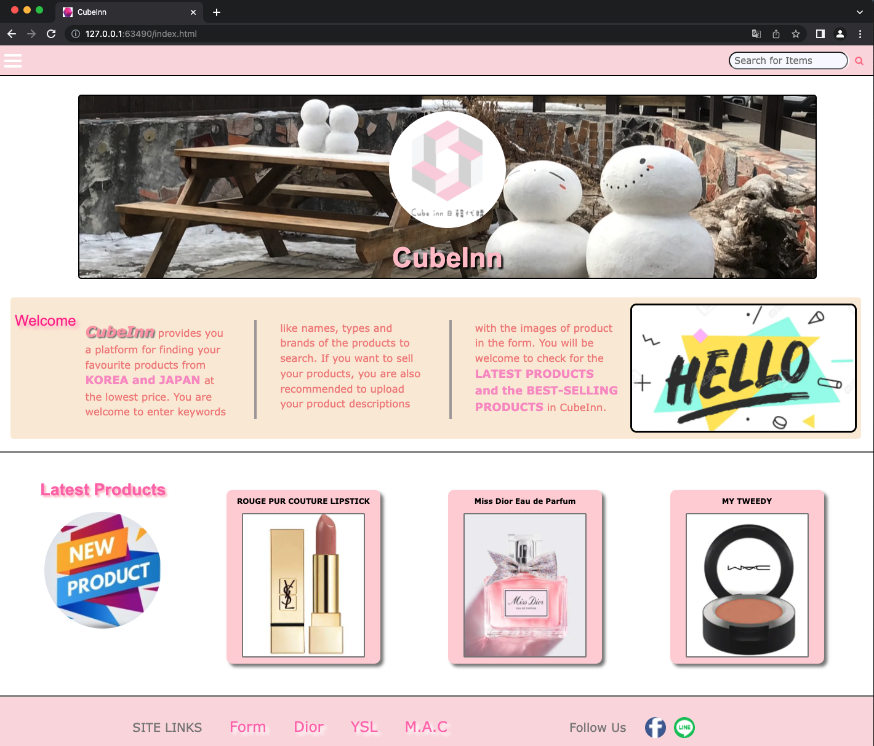

This is the index page (home page) of our website. There are several buttons and effects that you might find it funny or useful and they would be introduced in the following parts.

Effect (1):

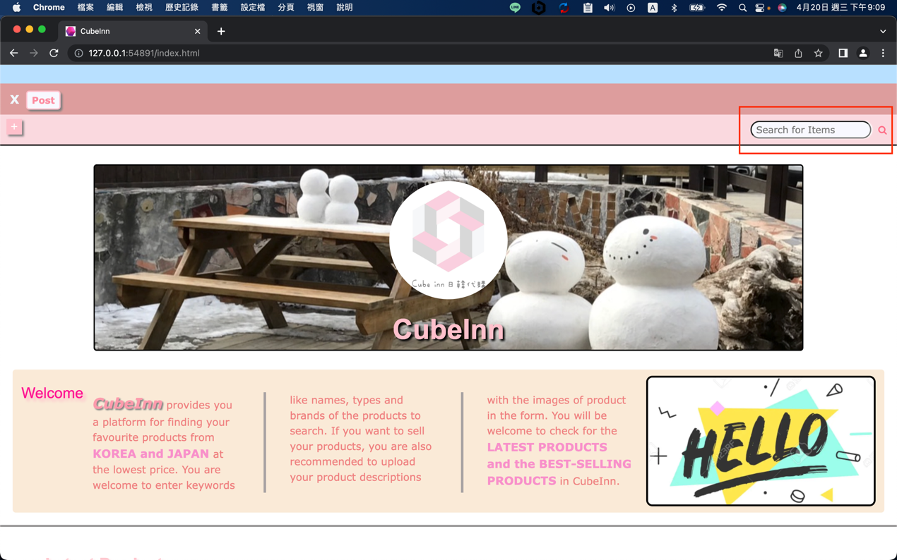

There is an input area in the top-right corner for you to enter the keywords of the products such as the product name or the brand name. After entering the keywords, you can press the “search icon”.

HTML Code:

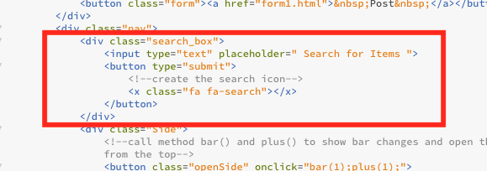

CSS Code:

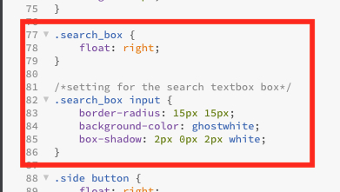

Effect (2):

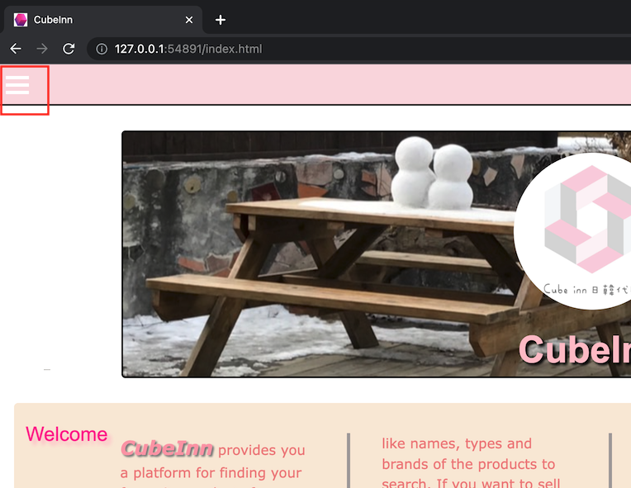

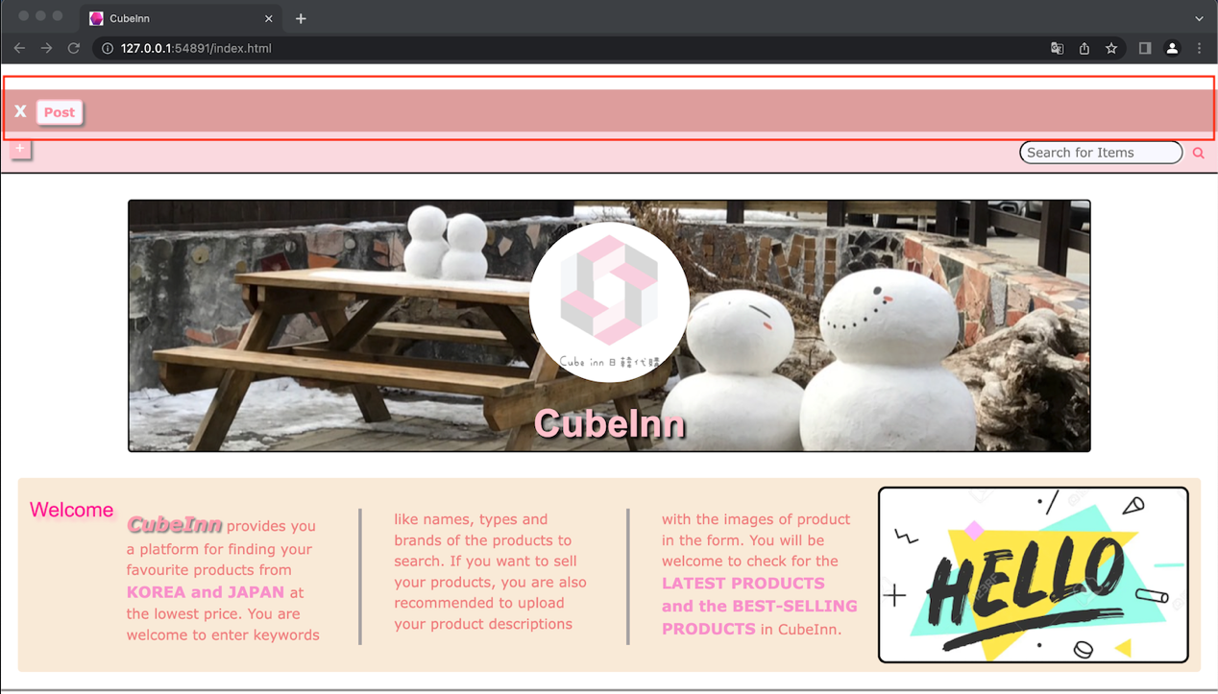

If you click the hamburger button in the top-left corner, a sidebar would be shown in the webpage. If you want to post your product for sale, you can click “Post” for uploading your products’ information to the platform.

HTML Code:

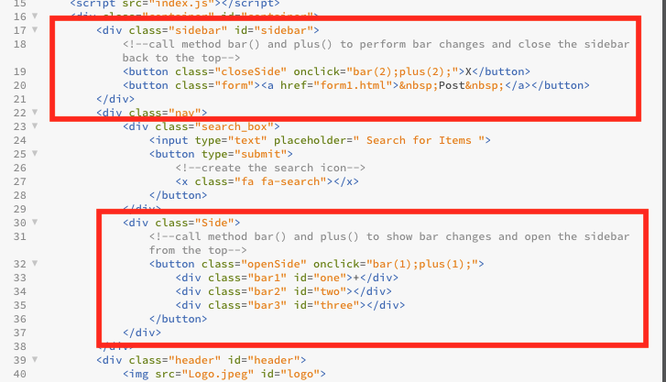

JavaScript Code:

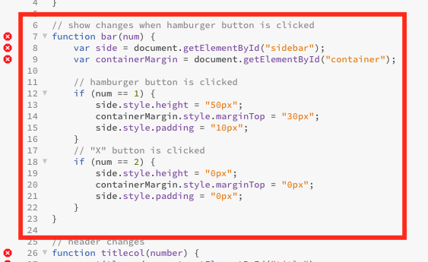

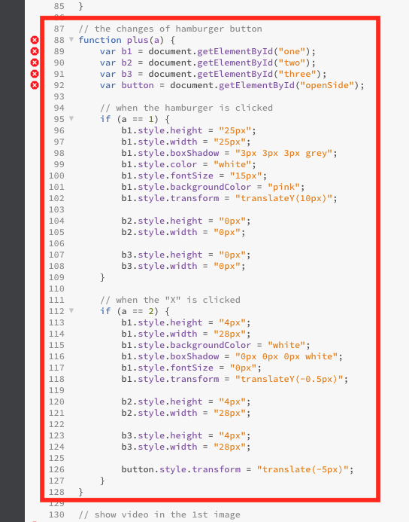

Effect (2):

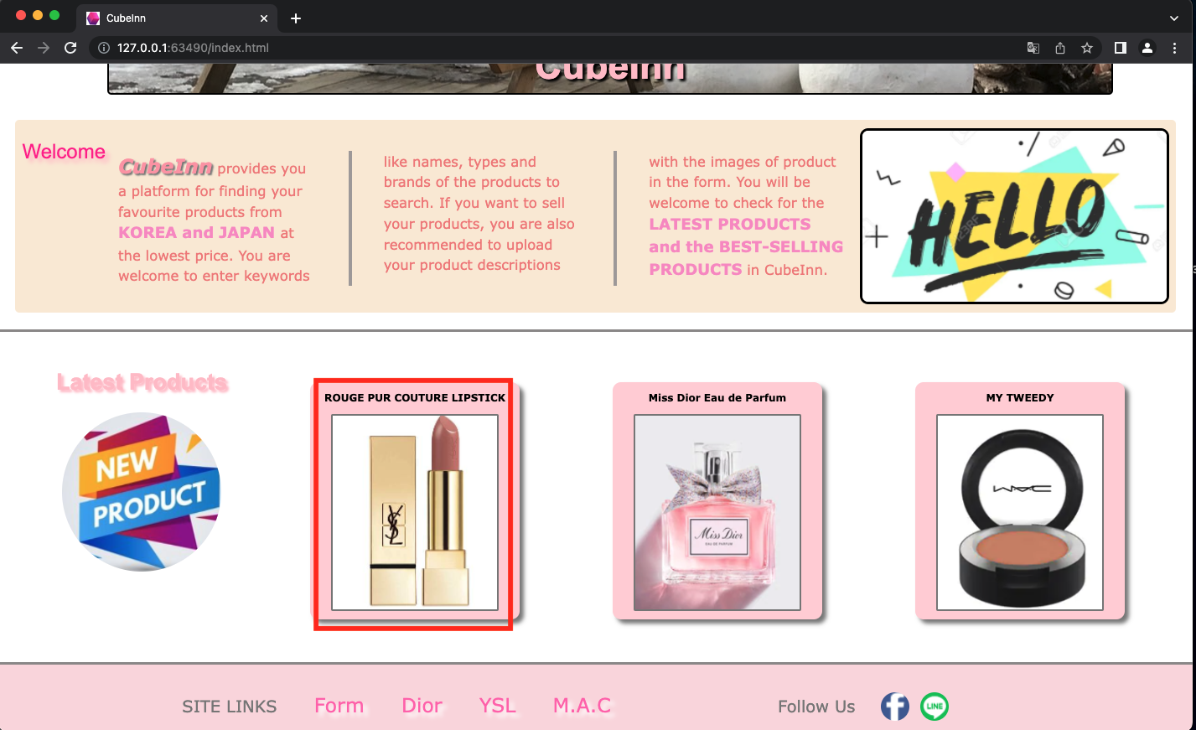

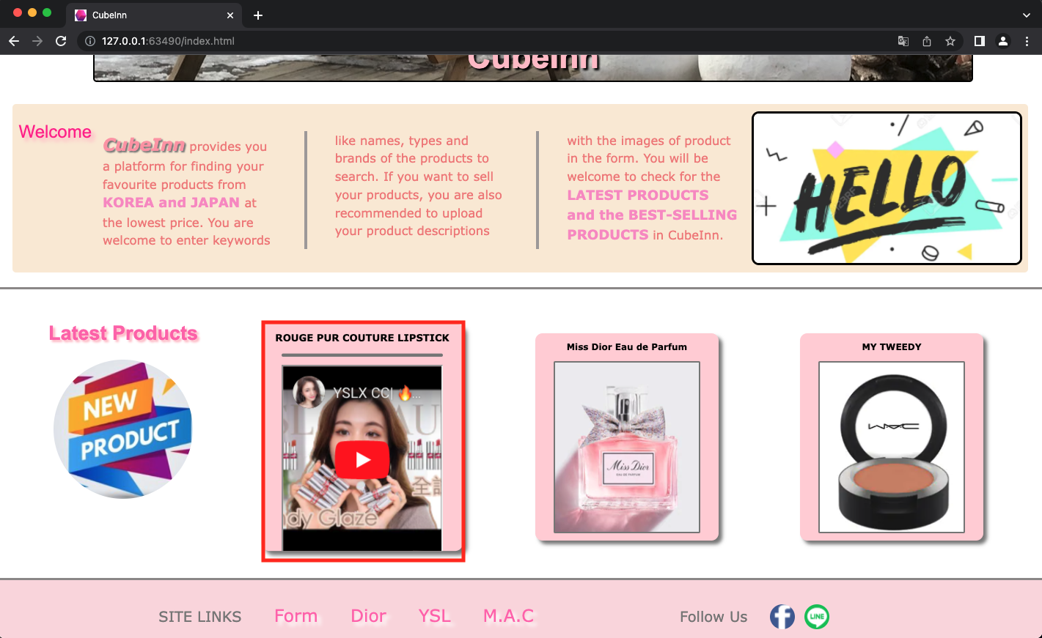

There is a video storing behind the product photo 1 (the left one). When the user’s mouse hovers the product area 1, the product area will firstly enlarge and the image will disappear. Then a video of the product will be shown.

HTML Code:

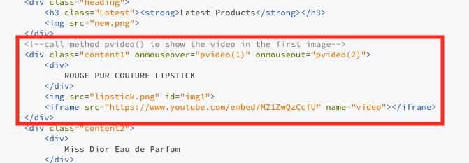

CSS Code:

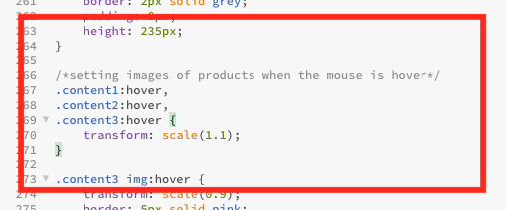

JavaScript code:

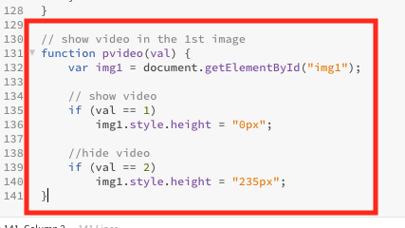

Effect (3):

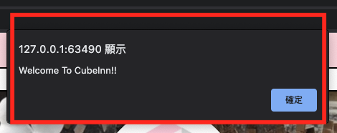

When user loads the webpage, there will be a welcome message.

HTML Code:

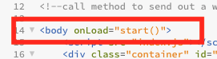

JavaScript Code:

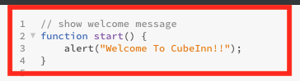

Effect (4):

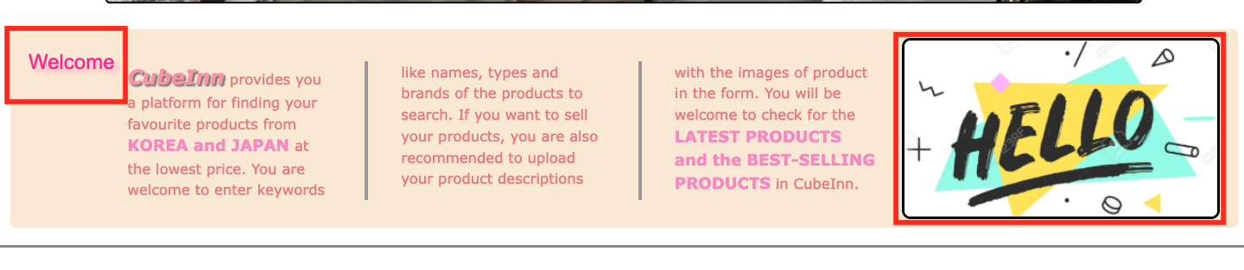

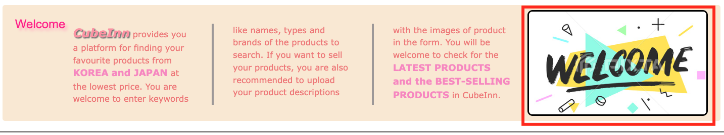

When the user holds over the introduction paragraph, the image will be changed from “Hello” to “Welcome”.

HTML Code:

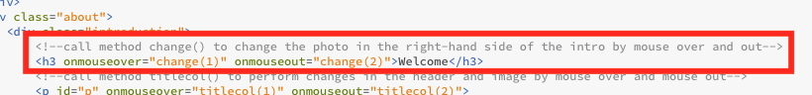

JavaScript:

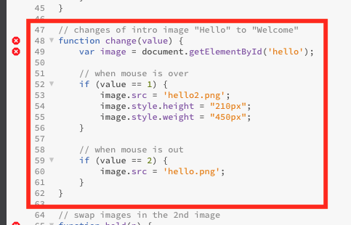

Effect (5):

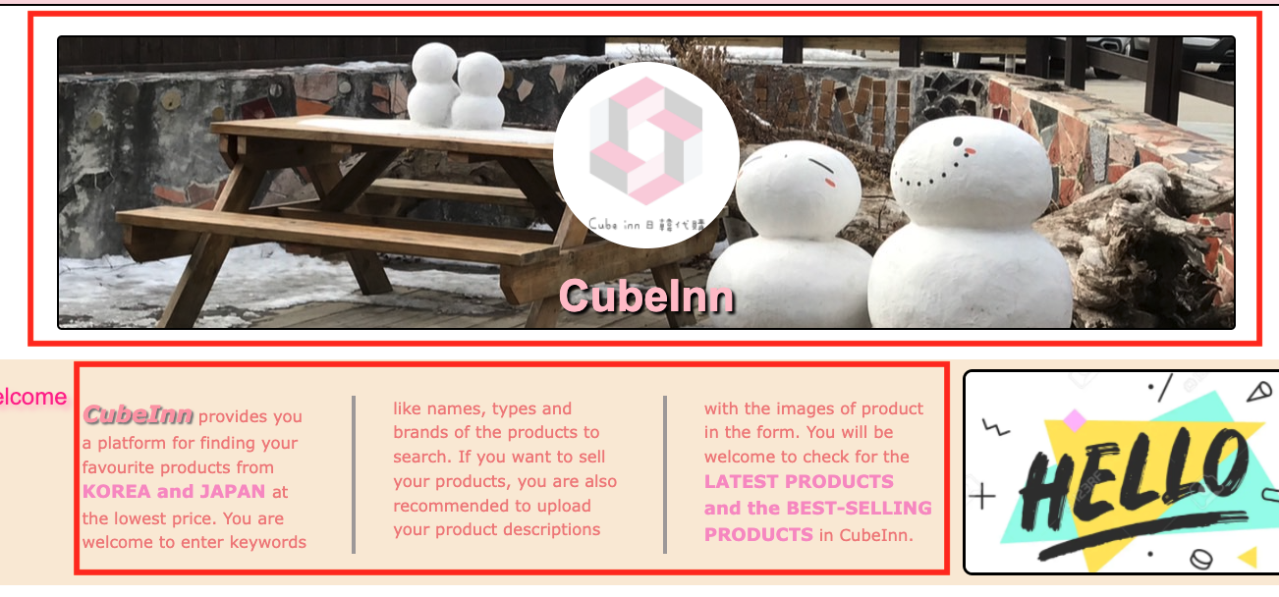

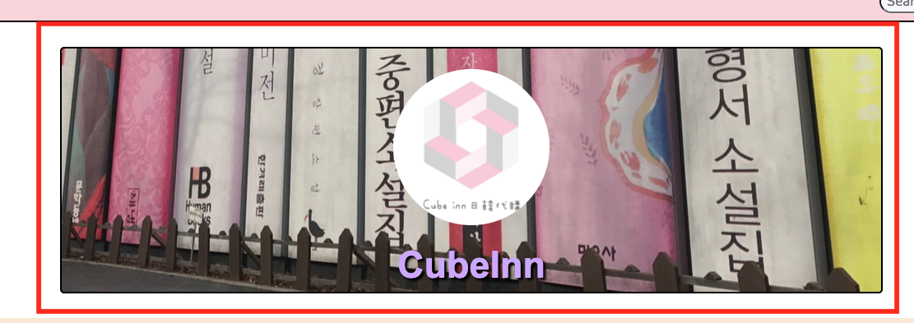

When the user holds over the introduction paragraph, the background image and the webpage name “CubeInn” in the header part will have changes.

HTML Code:

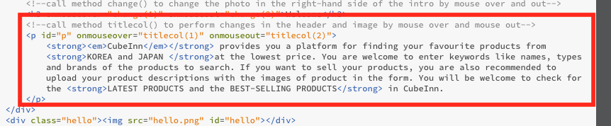

JavaScript Code:

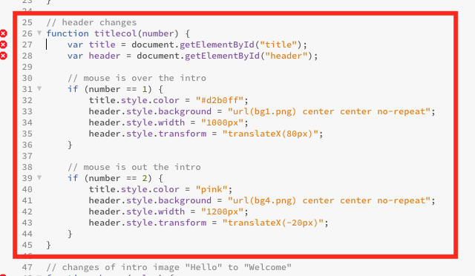

Effect (6):

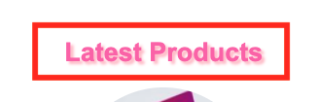

The header “Latest Products” can shine, which is made of CSS code.

CSS Code:

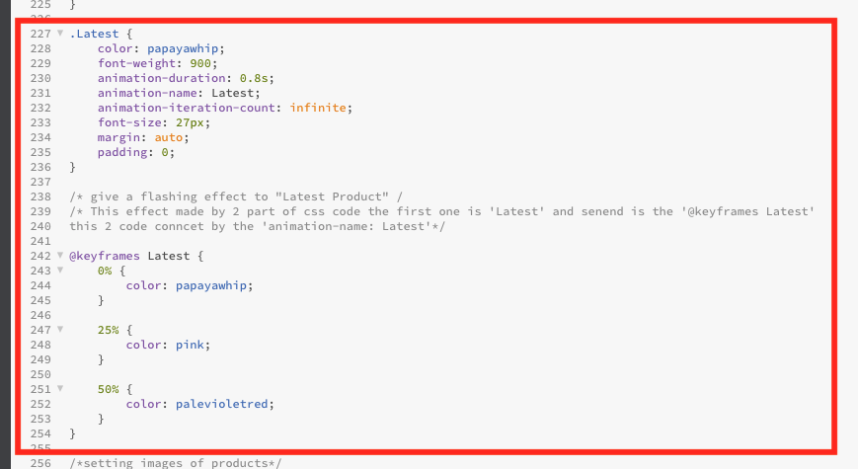

Effect (7):

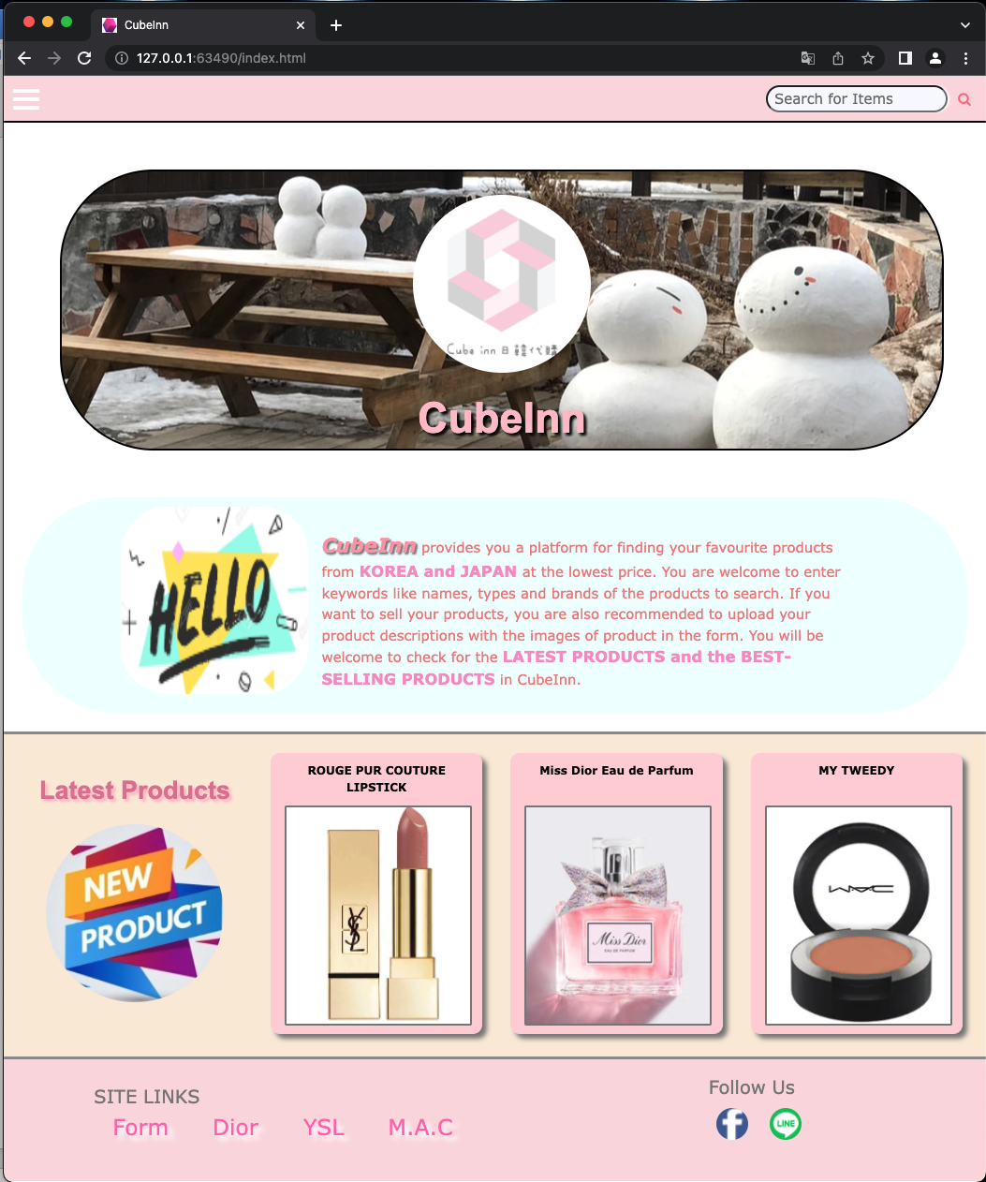

When the width of browser is between 500px and 1200px, the screen of the webpage will be displayed in this way.

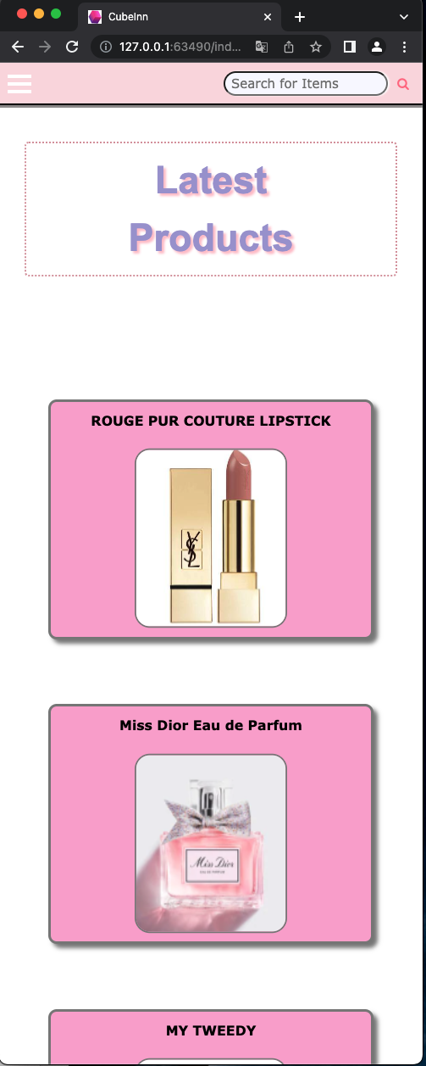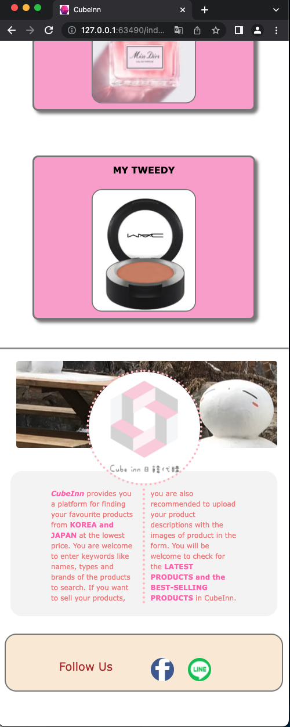

When the width of browser is between 500px and 1200px, the screen of the webpage will be displayed in this way.

CSS code:

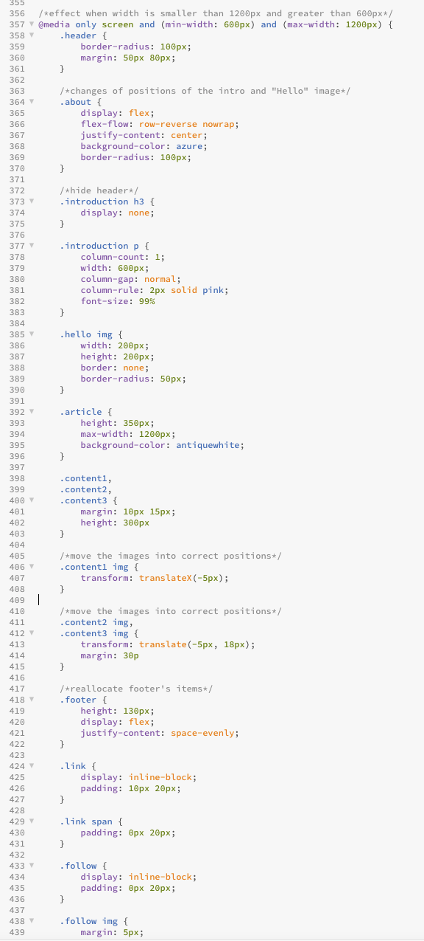 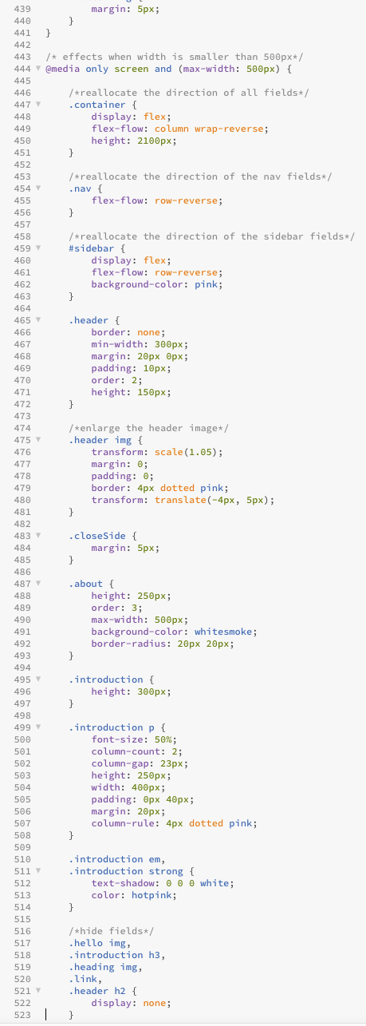

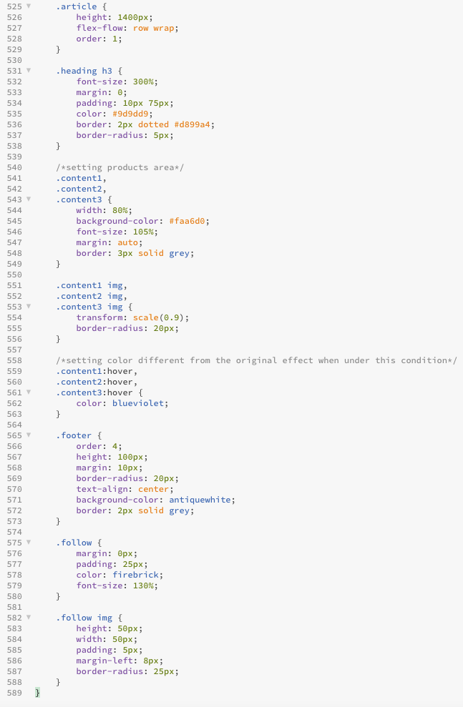

Post Page (Form):

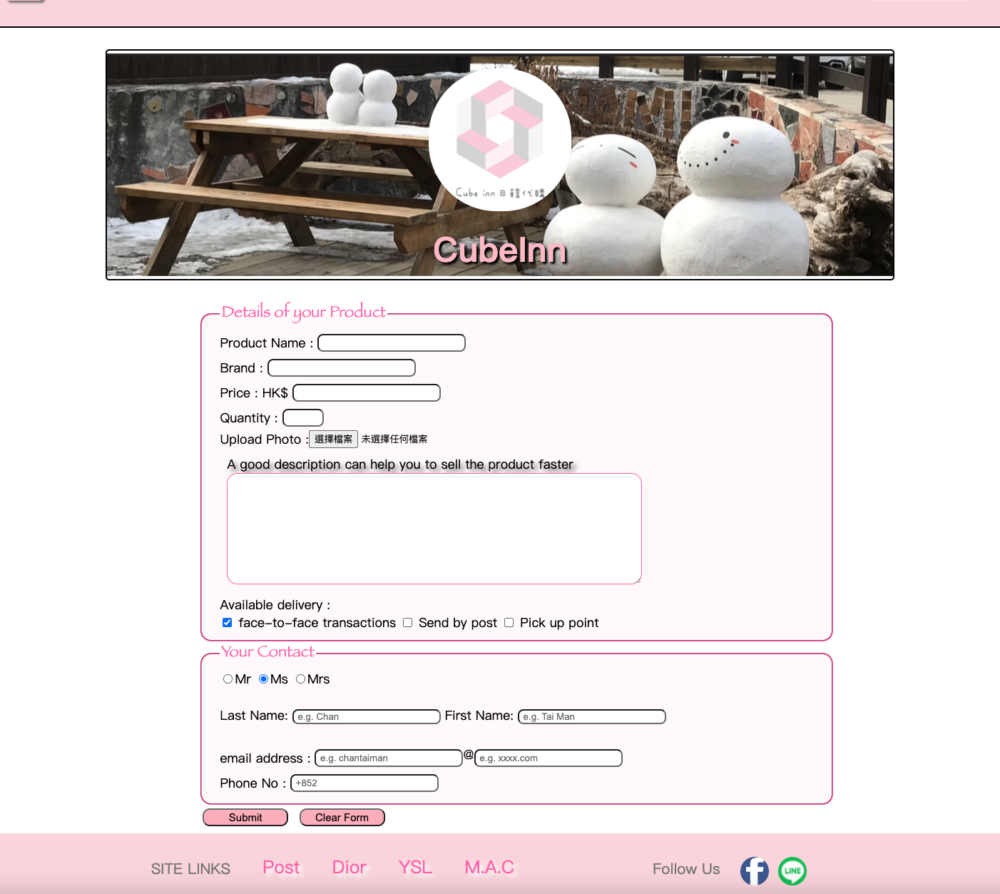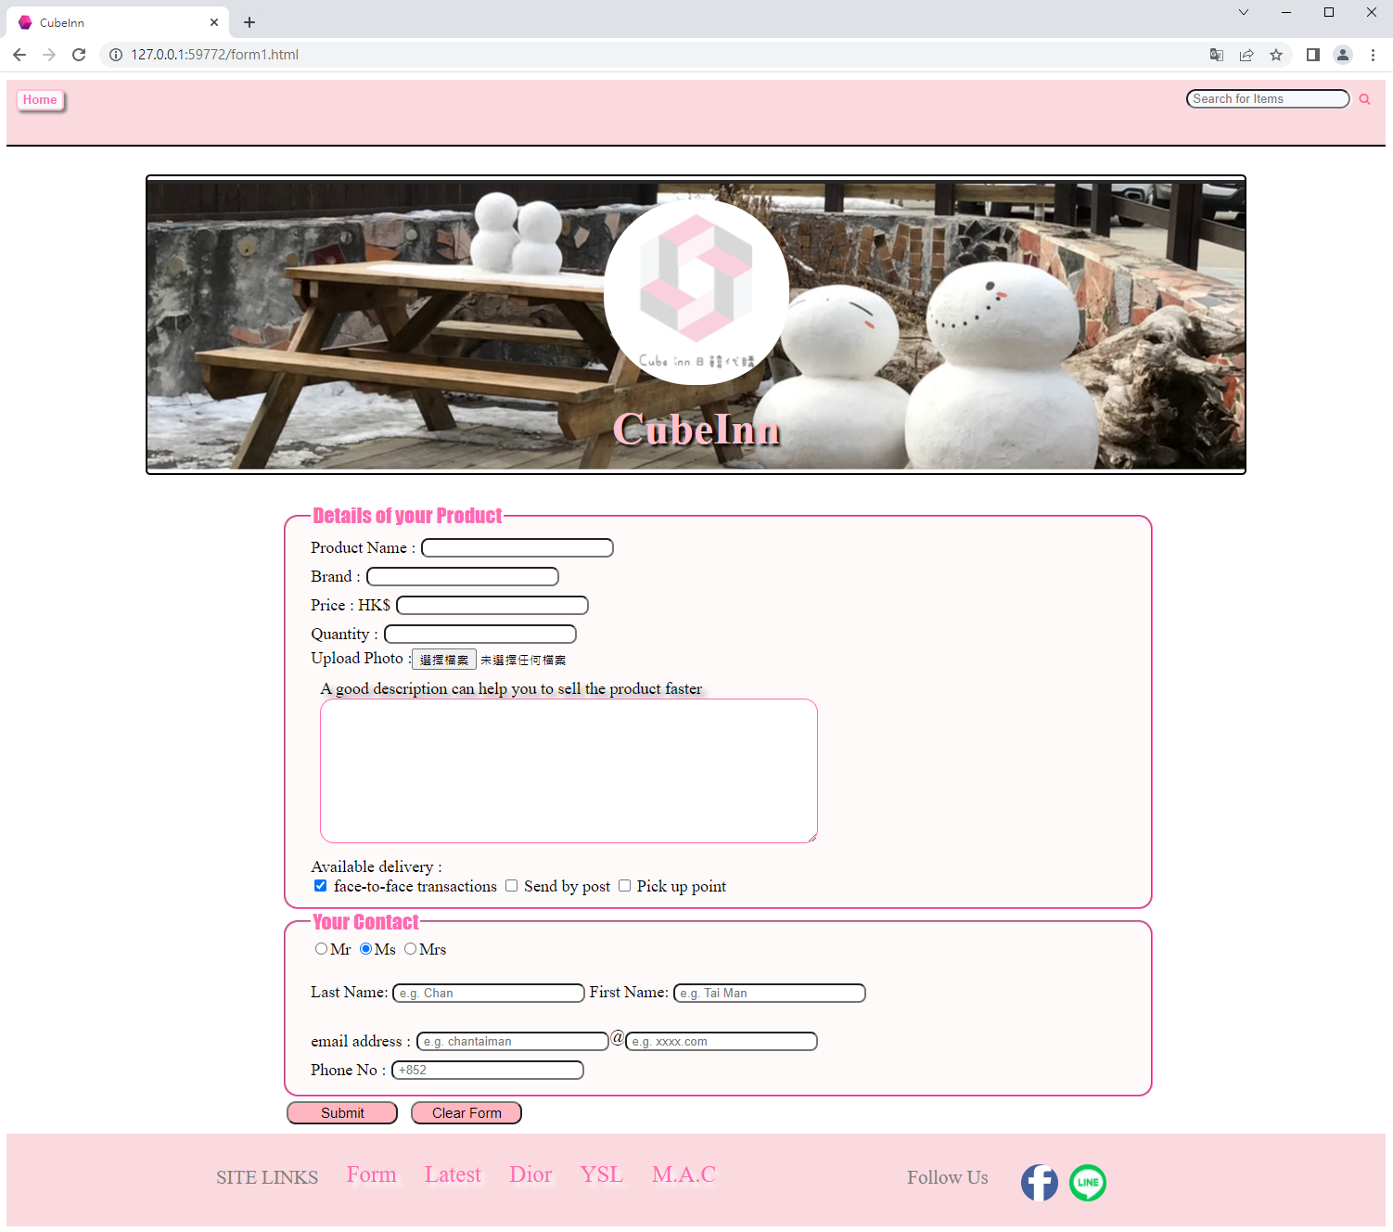

This is the Post page (Form) of our website. There are several textboxes for user to enter the information.

Let’s talk about how to use this form.

Effect (1):

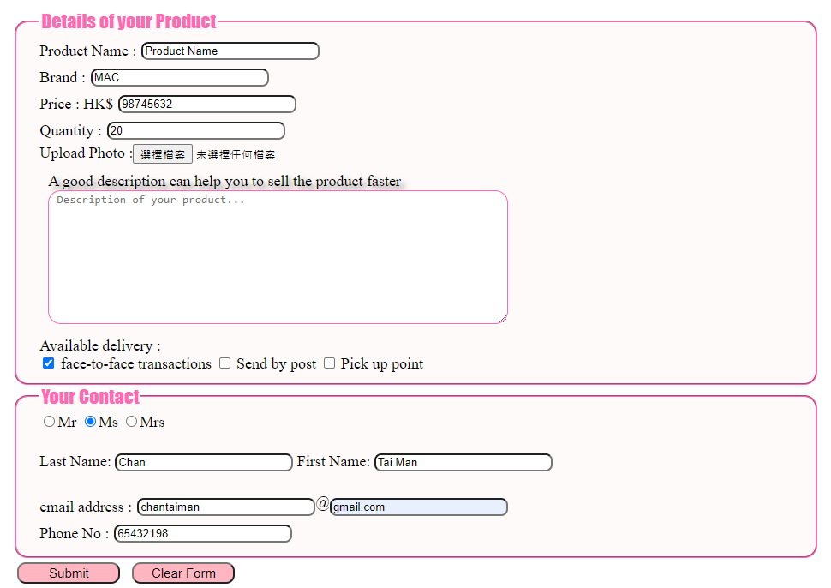

The user should fill in all the textbox, except the “Desc text box”, and then click submit button.

After clicking the submit button the webpage will pop a success message.

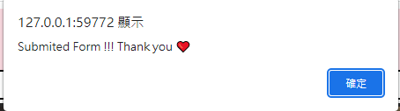

This message made by JS code:

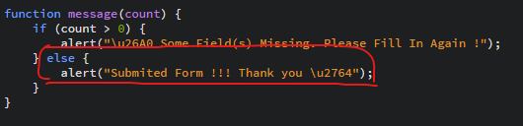

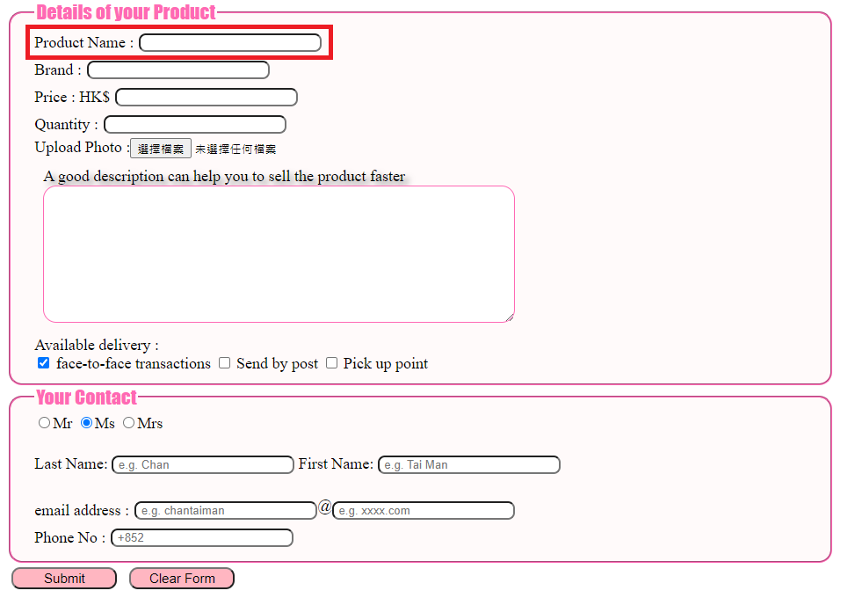

Let’s see the input box.

The user can type character or number into this box. However, it cannot be empty. Else, it will pop a warning.

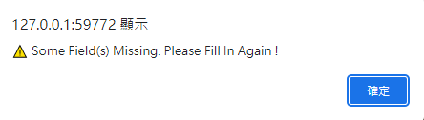

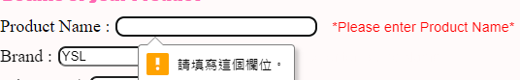

Those error message made by HTML CSS and JS:

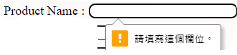

This part made by this HTML code:



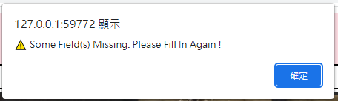

This part made by JS code:

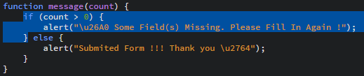

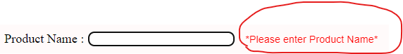

This part made by JS and CSS code:

JavaScript:

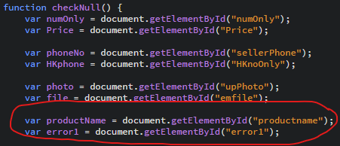

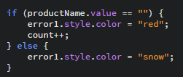

CSS:

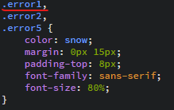

HTML:



Effect (2):

About the “Brand” textbox, which is a ‘datalist’ HTML code. It helps the user do the quick input.

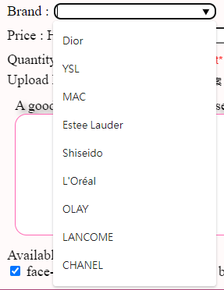

HTML:

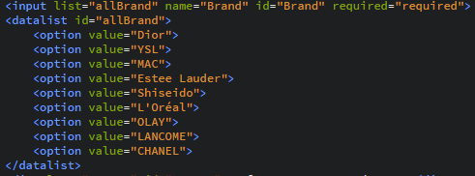

Effect (3):

When clicking the logo, the webpage will bring back to the ‘index.html’(Homepage):

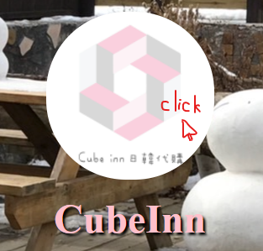

It made by a HTML code:



Product Description Page:

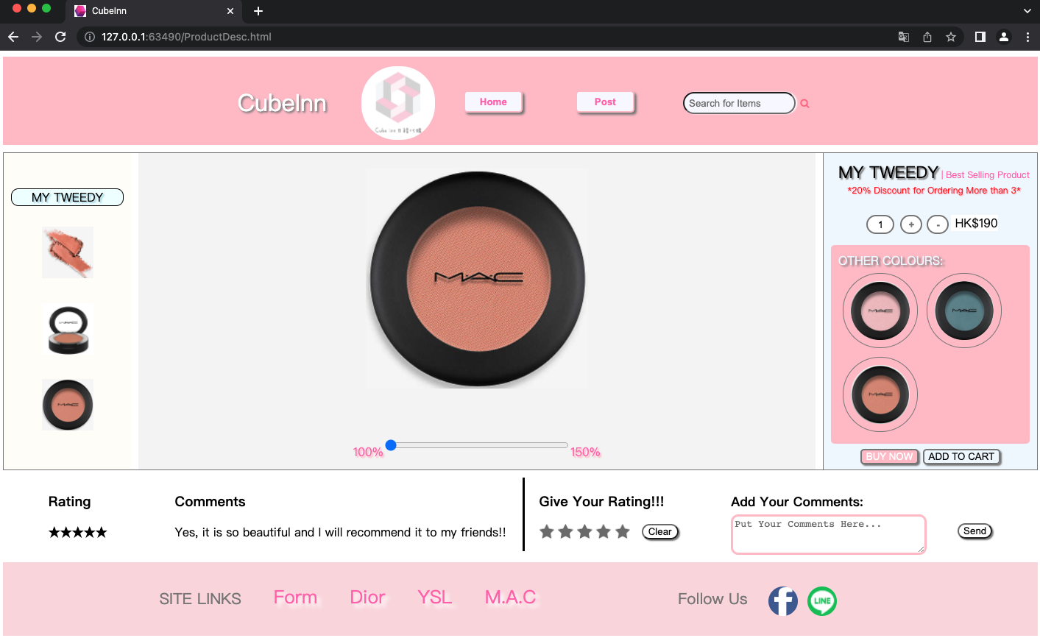

Effect (1):

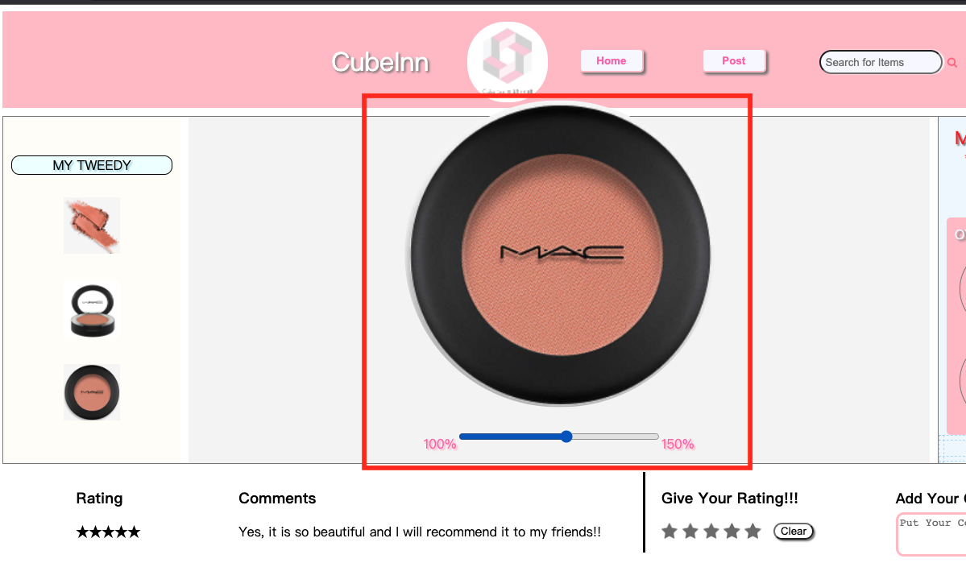

In the middle of the product description page, there is a range bar that can adjust the size of the main photo. The users can adjust the bar to the scale that they want to view the product. The maximum is 150% of the original size of image.

HTML Code:

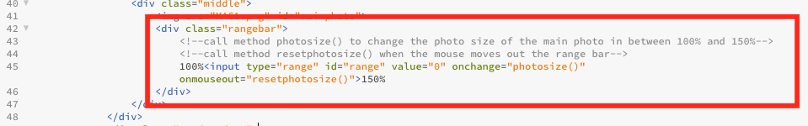

CSS Code:

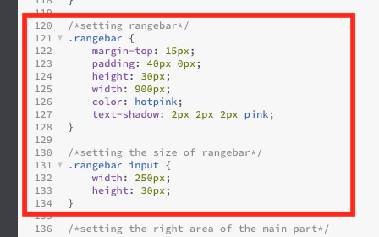

JavaScript Code:

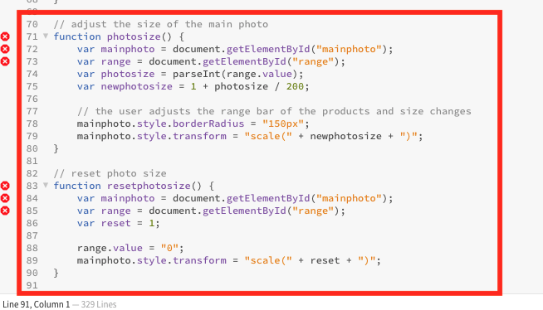

Effect (2):

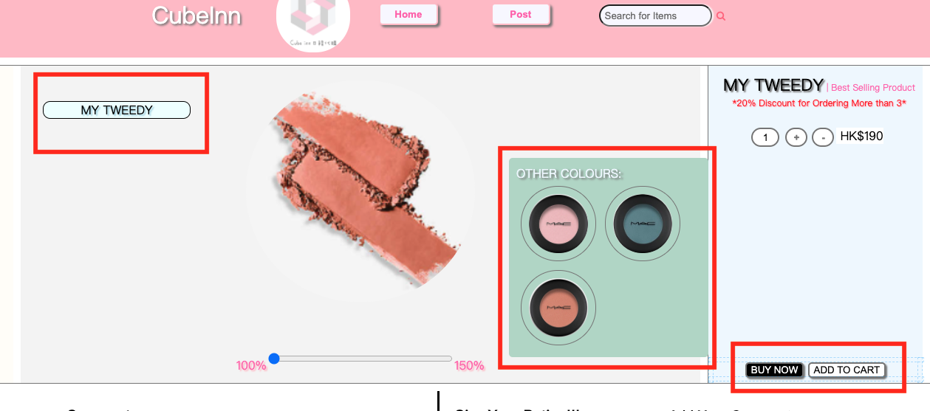

When the user’s mouse hovers the title “MY TWEEDY” in the left part, there will be an effect shown. The title and the other colors area will move to the middle slowly.

The other colors area will change the color from pink to green as well.

HTML Code:

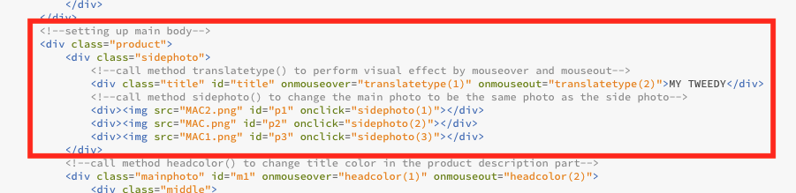

CSS Code:

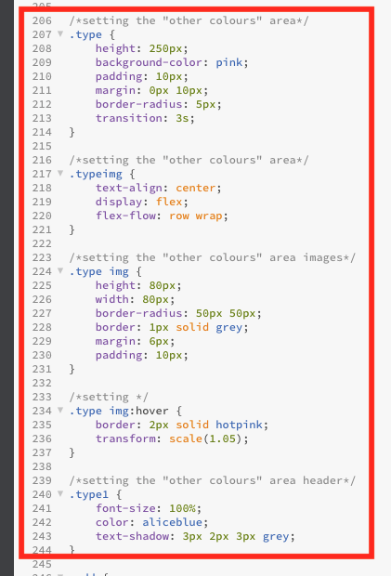

JavaScript Code:

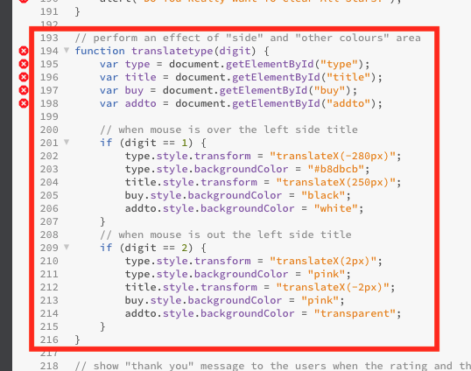

Effect (3):

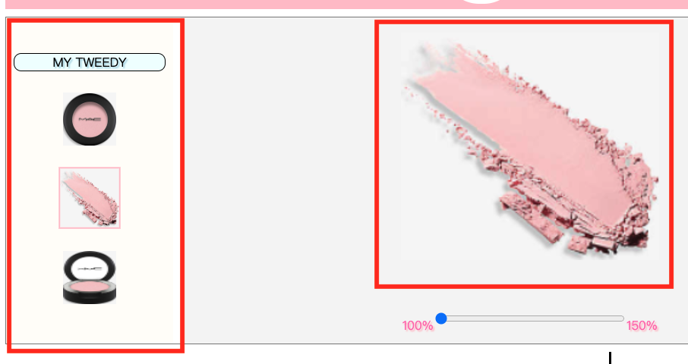

When the users click the side photo, the main photo will be automatically changed into the photo selected.

HTML Code:

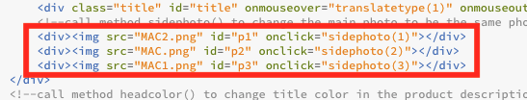

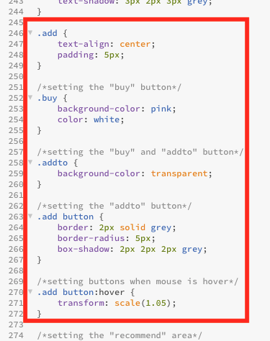

JavaScript Code:

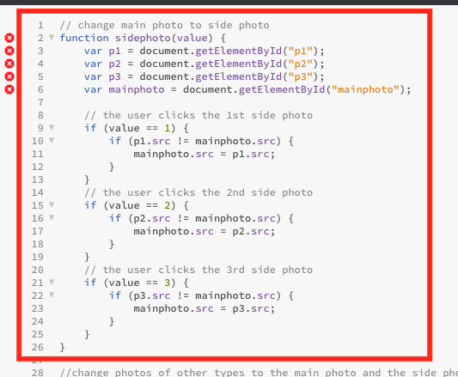

Effect (4):

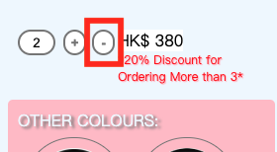

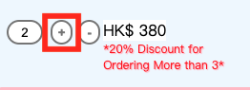

The “+” and “-“ buttons can be used for controlling the quantity that the users want to order.

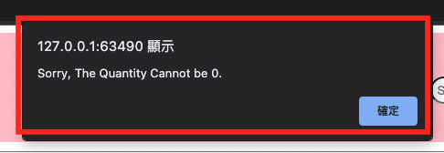

However, if the quantity becomes 0, an alert message will be sent.

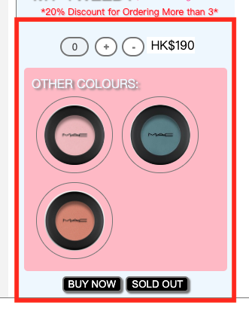

If the product is sold out, the quantity will be changed into 0. Meanwhile, all buttons are not allowed to be clicked.

HTML Code:

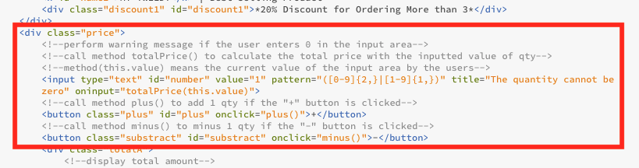

JavaScript Code:

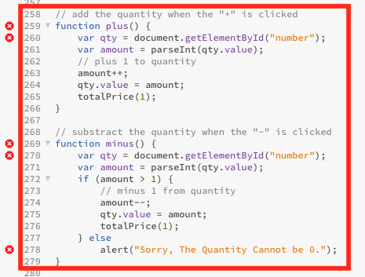

Effect (5):

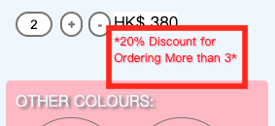

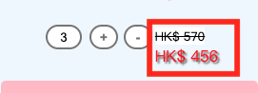

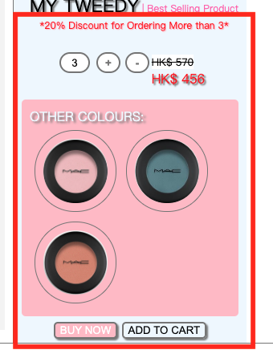

If the users order for more than 3 of the same products, there will be a discount.

Originally, the discount message is shown below the title. When the users start ordering 1-2 products, the message will be shown below the price. Start from 3, the discount message will display back below the title and a new price with discount will be shown below the original price.

HTML Code:

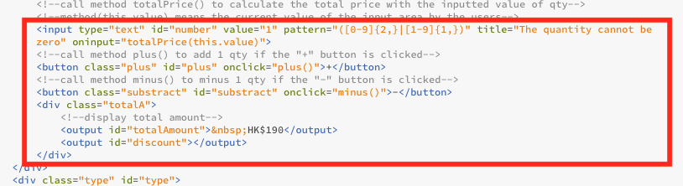

JavaScript Code:

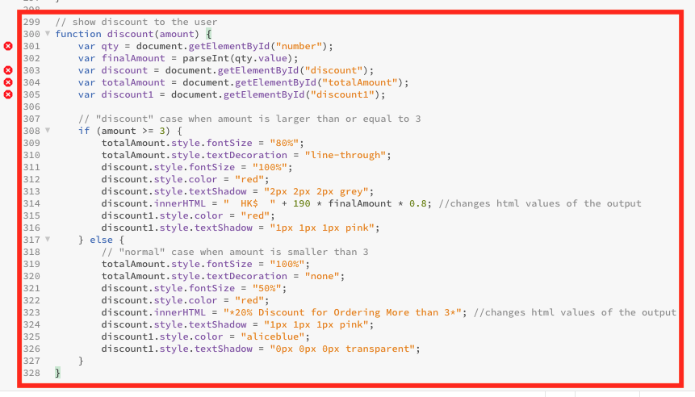

Effect (6):

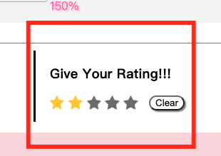

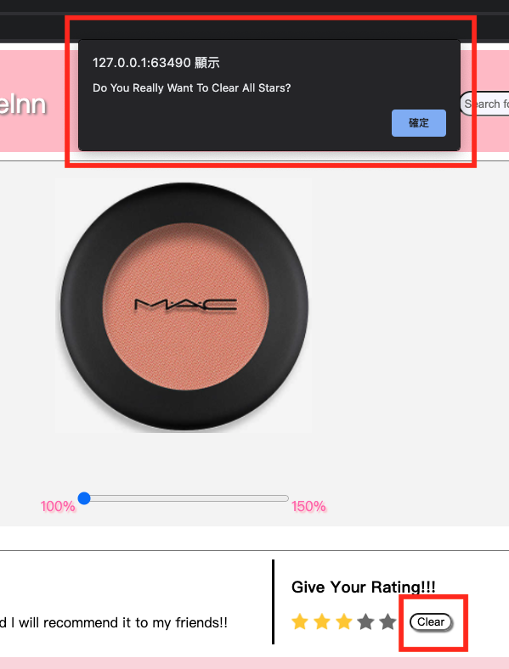

The user can rate stars on the website. After the users click on star, the star will light up. If the users want to reset the rating, they can click “clear” and the stars will be reset into dark. Meanwhile, an alert message will be shown.

HTML Code:

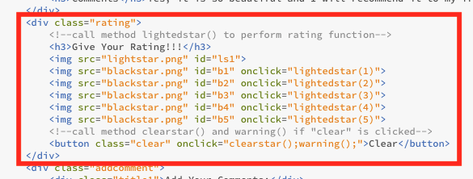

JavaScript Code:

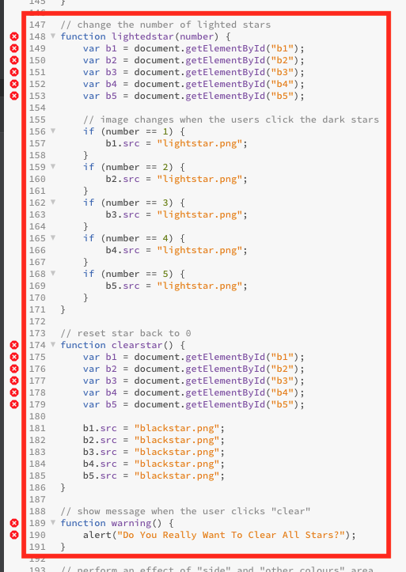

Effect (7):

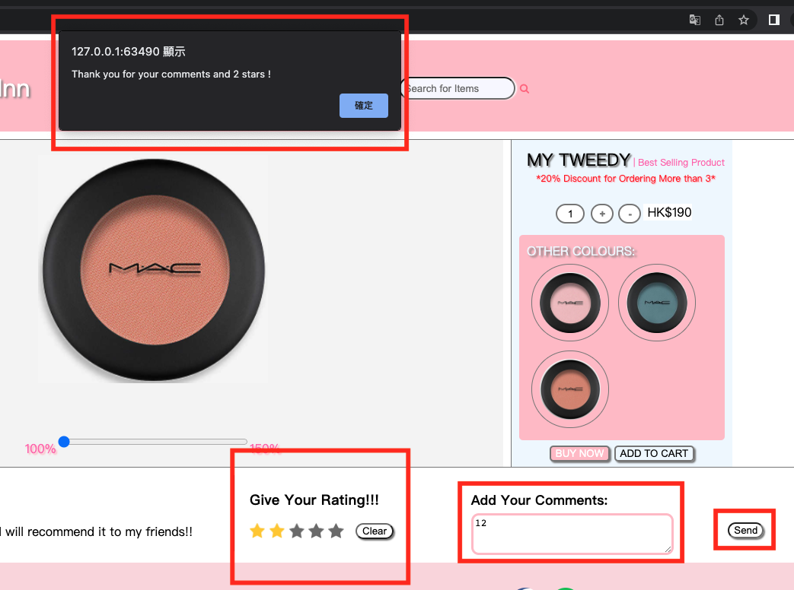

A “thank you” message will be shown if rating and comments are sent.

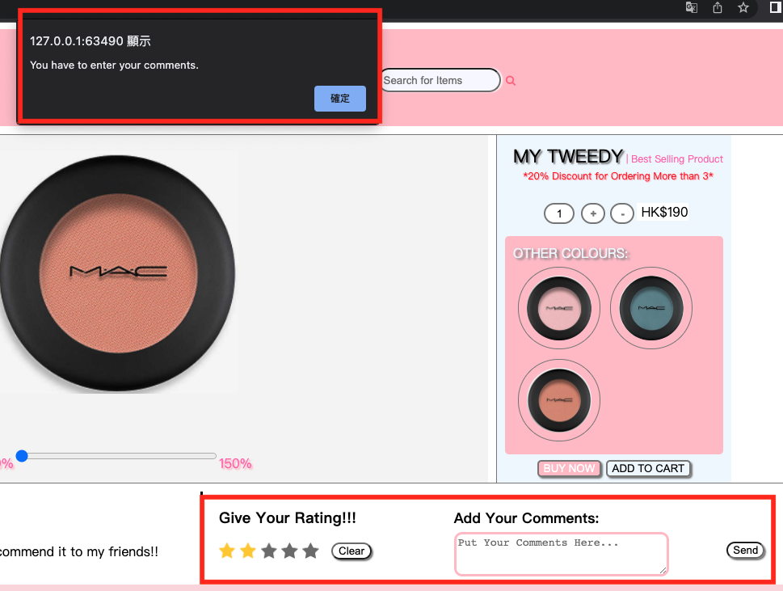

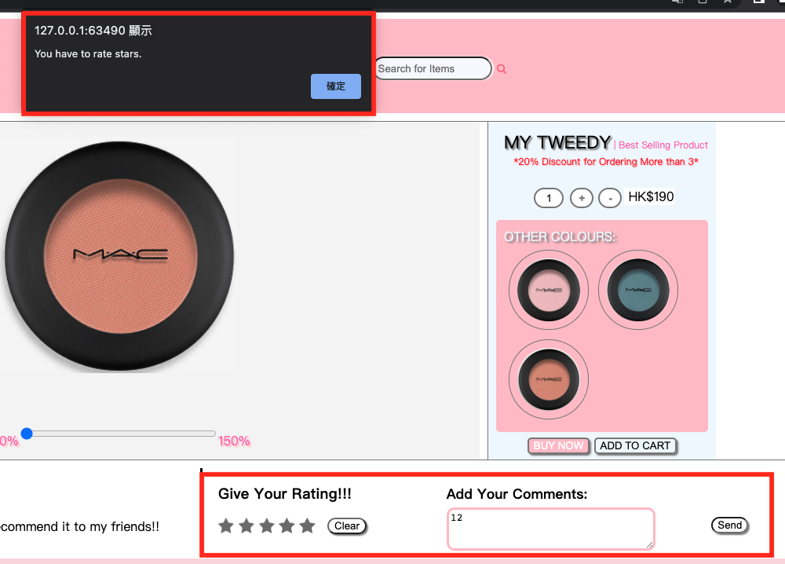

If either the comment area or the rating area has not been done, there will be a message to notice the user to enter it again.

HTML Code:

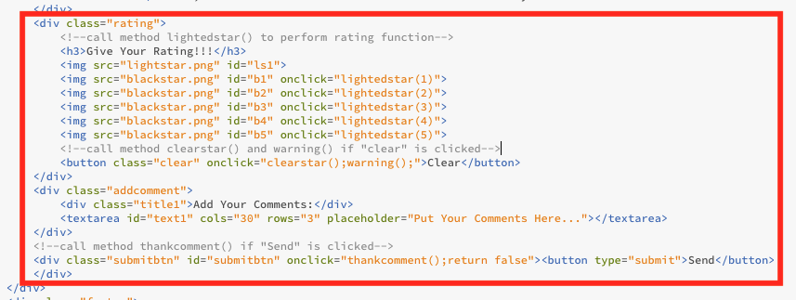

JavaScript:

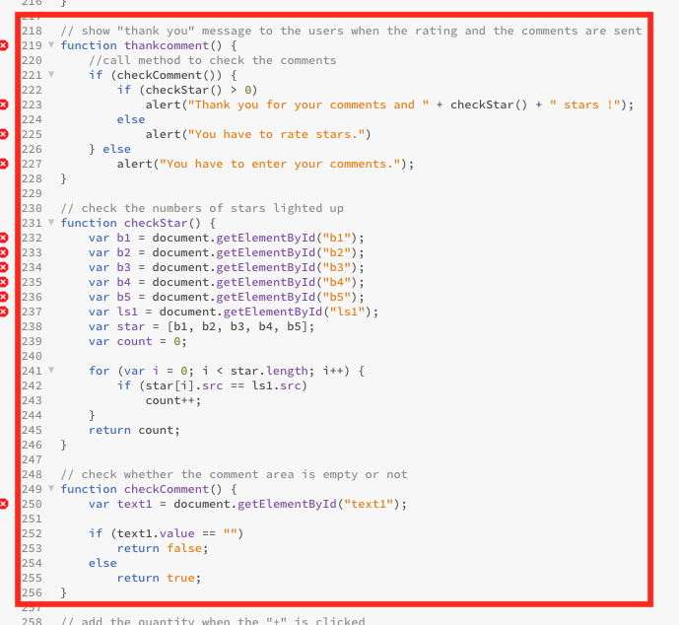

Effect (8):

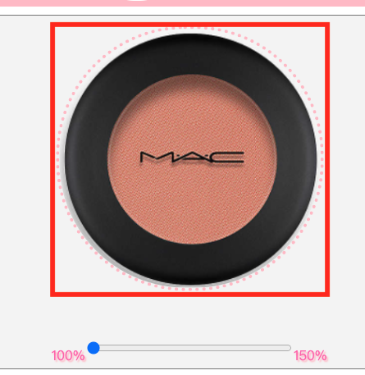

When users hold over the main photo, the main photo will enlarge 105% with a pink dotted border, which is made by CSS code.

CSS Code:

